13.77: Take only the positive root (to get the least time), so that

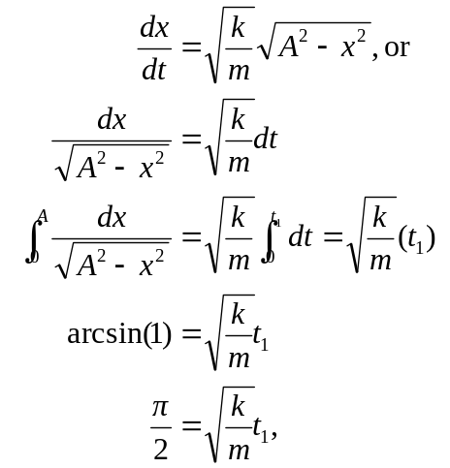
where the integral was taken from Appendix 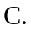 The above may be rearranged to show that 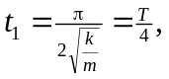 which is expected.

